`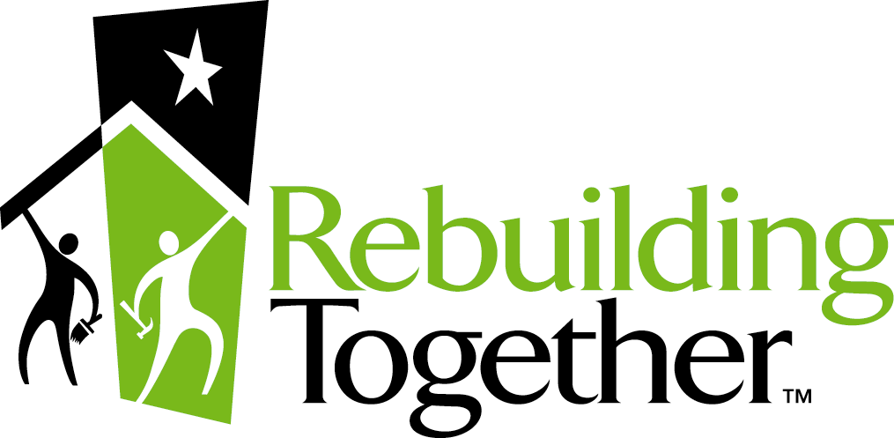
P.O. Box 72216
Los Angeles, CA 90002
(310)532-6700
fax(310)532-6715

Greater Los Angeles

Volunteer Registration & Waiver of Liability
YES! I would like to participate in the Rebuilding Together Greater Los Angeles project on
_____March 15, 2008___________ __ from _8:00am_ to _12:00pm_ or until the work is done.
I understand that you will provide me with my assignment(s) and further details prior to the project.
Please Print:

Name: __________________ _____Daytime Phone: ______________ Evening Phone: _________________

Address: _____________________________ City: _____________________ State: ____ Zip: ___________

E-mail: _____________________________Company/Group: ____________________T-Shirt Size: ______

Emergency contact: ___________________________ Emergency contact phone: ____________________

I can offer the following skills:
Painting | Electrical | Yard work
Drywall | Plumbing | Other__________________
Glazing | Fencing | General Unskilled
Carpentry | Cleaning | Assisting with clerical work
Floor/Carpet Laying | Landscaping | Whatever needs to be done

Waiver and Release of Liability
In consideration of the opportunity afforded me/my child to assist on a voluntary basis in the Rebuilding Together Greater Los Angeles repair project, a project in which the homes/organizations of disadvantaged persons will be repaired by volunteers (“Project”), I hereby agree that I, my successors, assignees, heirs, guardians and legal representatives will not make any claim against Rebuilding Together Greater Los Angeles, nor any of their affiliated organizations or their officers, directors, employees, or suppliers of any materials or equipment used in the Project, any of the Project volunteers or sponsors, or any community center or homeowner participating in the Project, for injury, death or damage resulting from the acts or omissions of any person or entity, however caused, arising from my/my child’s participation in the Project. Without limiting the generality of the foregoing, I hereby waive and release any rights, actions or causes of action resulting from personal injury, death to myself/my child or damage to my/my child’s property sustained in connection with my/my child’s activities in the Project. Consent, I further freely consent to the unrestricted use by Rebuilding Together and/or any person authorized by them of any photographs, recordings, interviews, videotapes, motion picture or similar visual or auditory recording of me created in connection with the Project, and I expect and anticipate no remuneration there from. Volunteers must be at least 14 years old.

______________________________________________ ______________________ Volunteer/Parent Signature Date
Signature here indicates that you have read and agree with the waiver and release.

